TC024 - Valid booking ID, update with invalid date:   
{"bookingdates":{"checkin":"invalid"}}

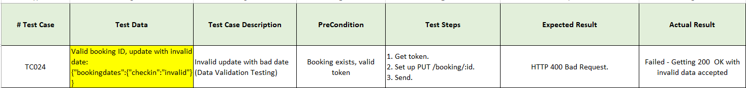

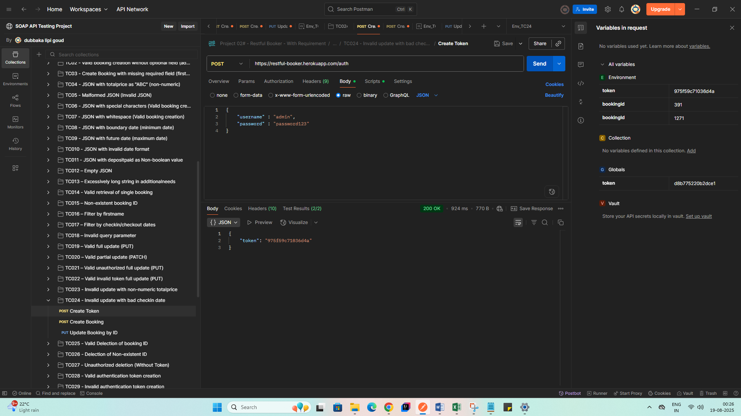

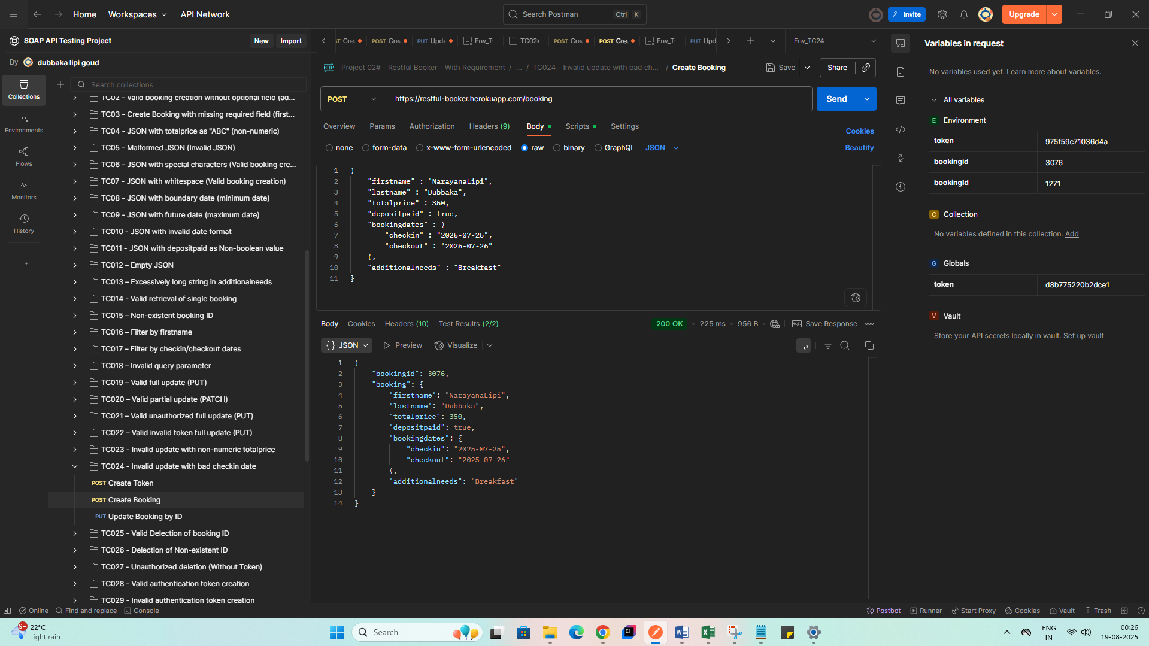

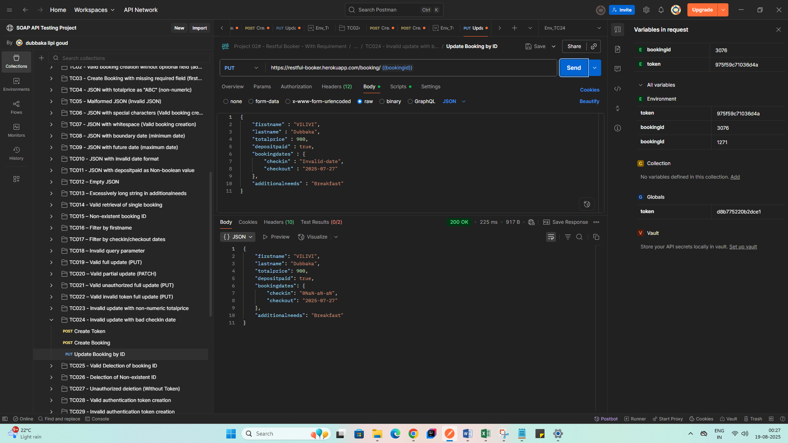

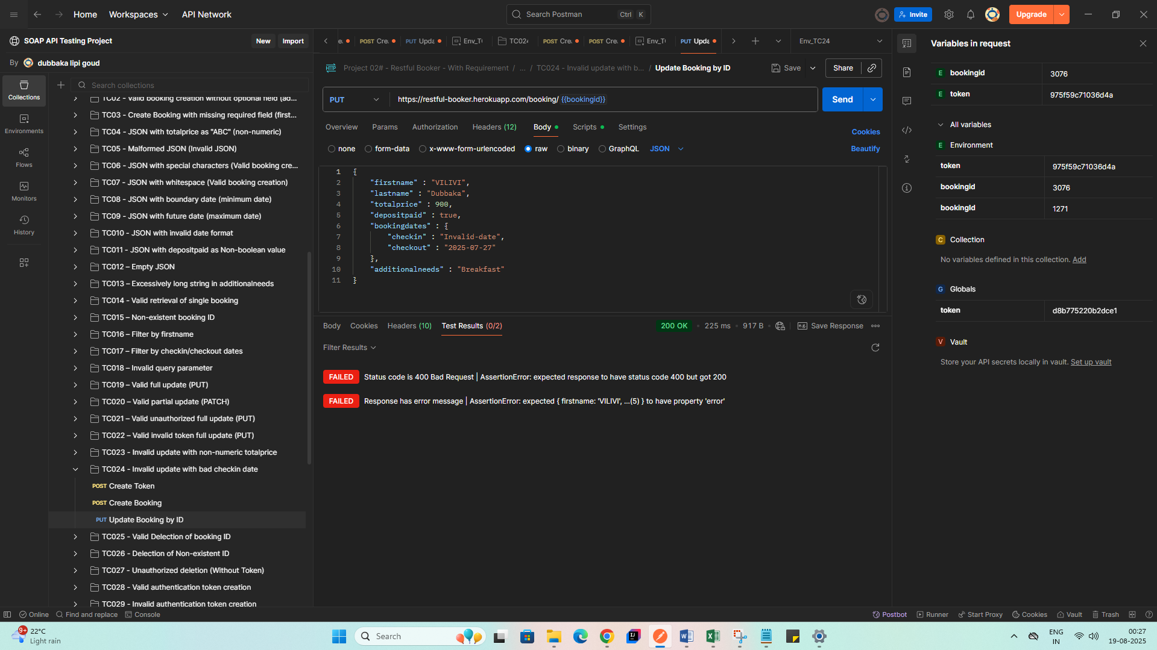

**Bug:** API did not validate date format; accepted invalid check-in date.

Expected Result:

* HTTP 400 Bad Request.

Actual Result:

* HTTP 200 OK with invalid data accepted